Comparison Results
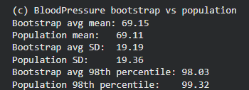
Plots
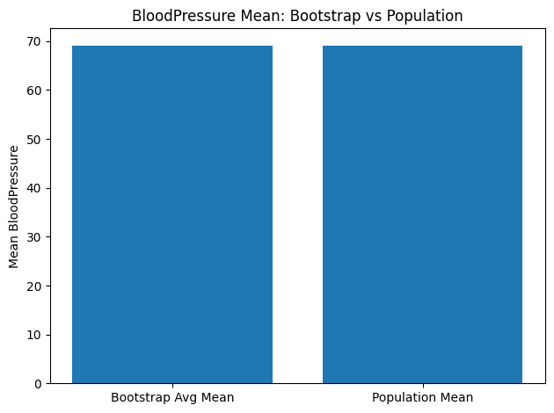
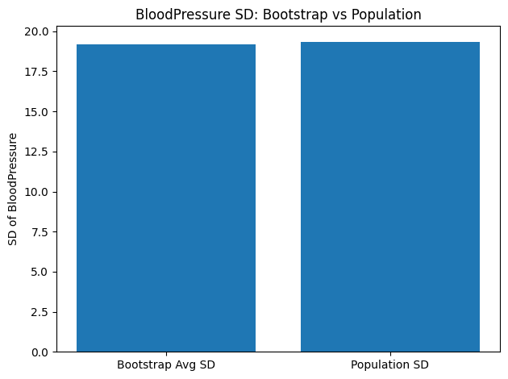
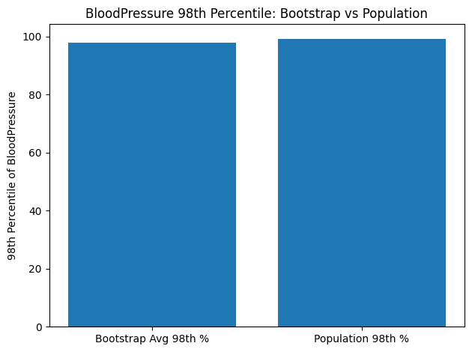
The bootstrap estimates [69.15] for blood pressure are very close to the population statistics mean [69.11] . The average bootstrap standard deviation [19.19] is also close to population standard deviation [19.36]. The 98th percentile from the bootstrap [98.03] is a little bit lower than the population 98th percentile [99.32].
This shows that the bootstrap provides a good estimate of true values. The margin of difference is very small and could very well be the result of variation in sampling, for example the boot strap does not take a similar value distribution as the population.

